MEDIA DIALOGUE WITH STAKEHOLDERS IN THE MEDIA INDUSTRY
The Uganda Media Sector Working Group and the International Center for Non-for-Profit Law organised a media dialogue on the necessary reforms in the media laws at Golf Course Hotel, Kamplala on Thursday, November 18, 2022. It was attended by Participants from various media associations & organizations amd academic institutions among which included; Media Council of Uganda, African Centre for Media Excellence (ACME), Uganda Media Women’s Association (UMWA), Nation Media, Makerere University, Kampala International University. Click for a full story https://www.newvision.co.ug/category/news/media-stakeholders-push-for-public-financing-NV_147726

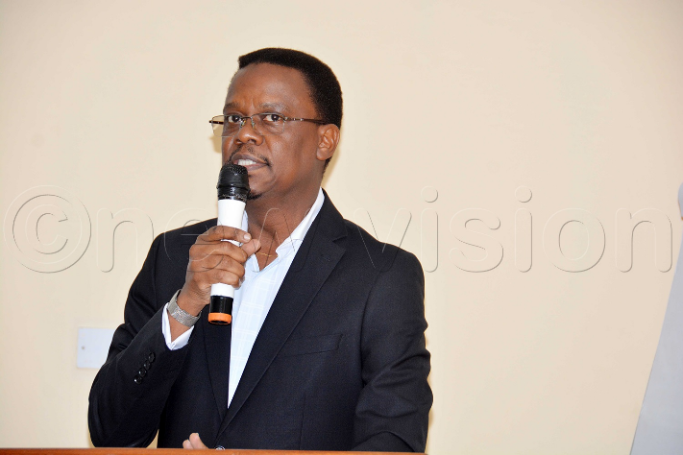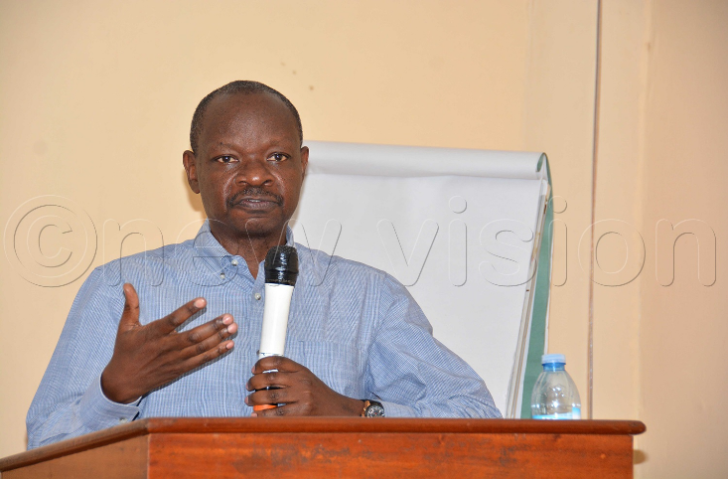
Mr Paulo Ekochu, Chairman Media Council of Uganda, (L) & Dr George Lugalambi, Executive Director ACME, (R) address participants during the dialogue.

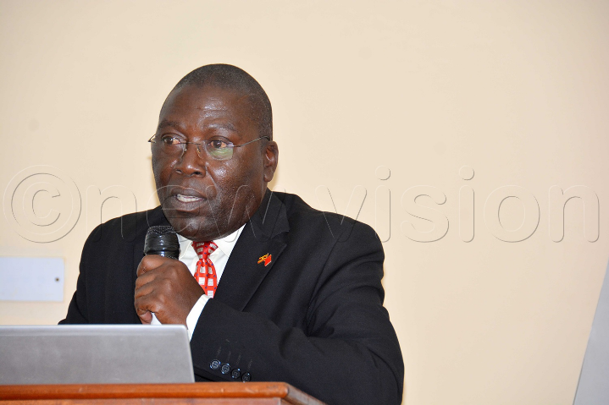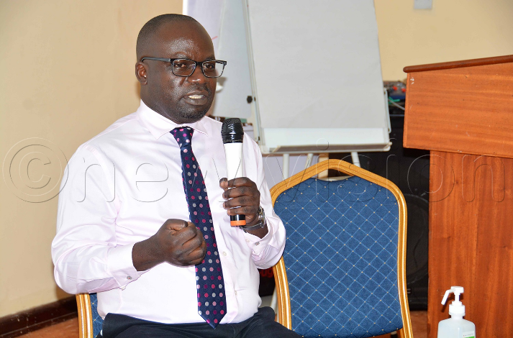
Mr Kyetume Kasanga, Secretary Media Council of Uganda, (L) & Mr Peter Okello Jabweli (R) address participants during the dialogue.

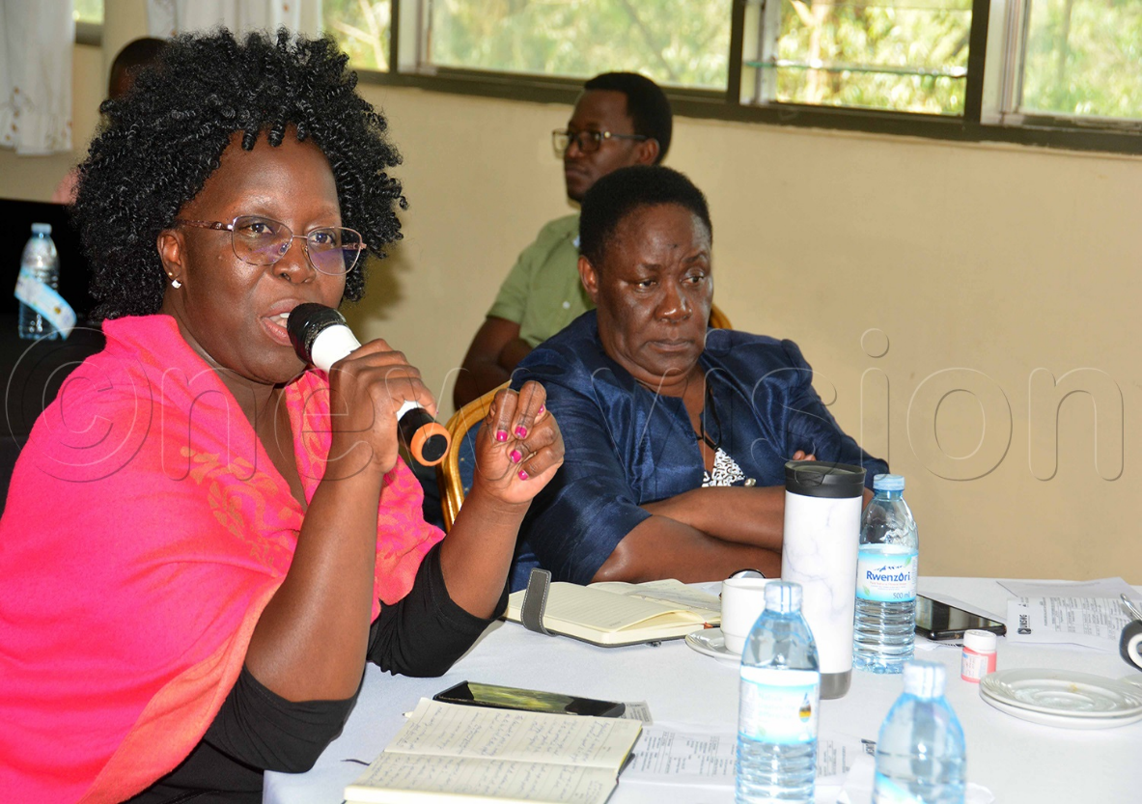
Dr Patricia Kevine Litho, Chairperson Board of Directors UMWA (L) & Ms Margaret Sentamu, Executive Director UMWA (R) address participants during the dialogue.

