TRIBUTE: SUMY SADURNI, PHOTOJOURNALIST WHOSE FOCUS WAS EAST AFRICA
By Annabelle Williams
March 21, 2022
Sumy Sadurni, a prolific photojournalist who documented human rights struggles, political resistance and gender issues in East Africa through a piercing and intimate lens, died on March 7, 2022 in Kampala, Uganda. She was 32. Her brother, Jorge Sadurni Carrasco, said she died in a car accident while travelling to take photographs in northern Uganda.
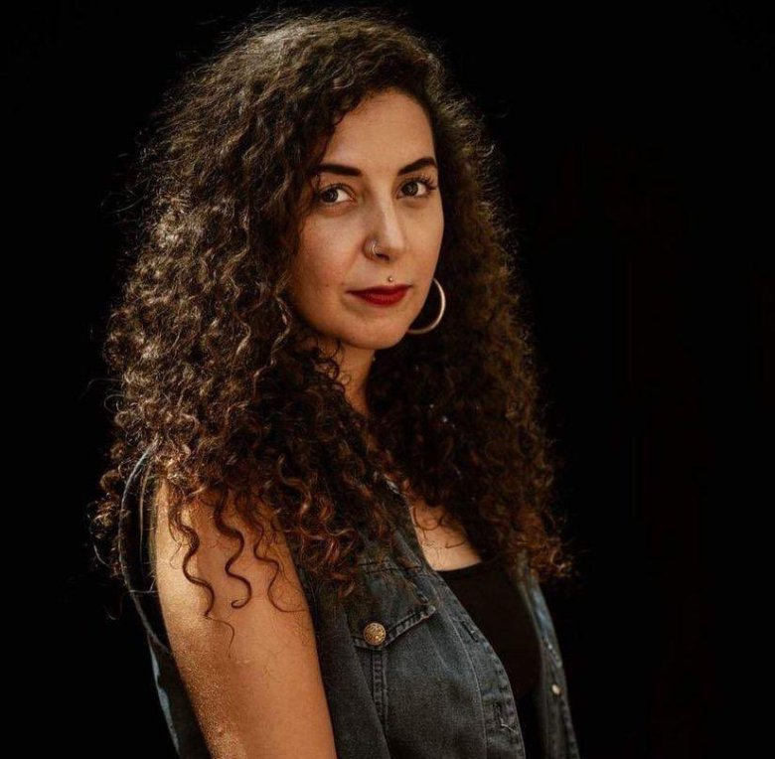
Thomas Mugisha, an NGO worker and her driver, also died in the accident. The head-on collision happened at around 8:30pm at Chopelwo valley in Kiryandongo district on Monday evening as the two were travelling back to Kampala. Faridah Nampiima, the Police’s traffic and road safety Public Relations Officer, confirmed the passing on of the two individuals.
Reports indicated that both Sumy and her driver died on spot after the car in which they were travelling, a Toyota Rav4 registration number UAS 597U, collided with a Fuso truck number UAL 192U.
Sumy, as she was known, was a talented, driven and courageous photojournalist with a rare gift for friendship. At just 32 years old, she had built a powerful body of work, which had been published in some of the world’s best-known publications; in 2020 she was shortlisted for the Guardian’s agency photographer of the year. She also leaves a legacy of knowledge and inspiration that she passed on to young photographers as a Uganda Press Photo award mentor, a teacher at Makerere University and a Canon trainer.
Mexican and Spanish by heritage, Sadurni grew up in Mexico and Switzerland, and later moved to the UK for university. She first came to Uganda in 2016 to visit a close childhood friend for two weeks. She stayed for three months, returned to the UK and bought a one-way ticket back to Uganda, starting from scratch as a freelance photographer.
She began working for AFP news agency, first in Uganda and later across the region, entering South Sudan’s war zone with armed rebels, and photographing female surgeons in Somaliland.
As a female freelancer, her calling was not easy. She had to fight hard to make a place for herself, and she succeeded brilliantly. Sadurni was as much a member of the Ugandan press pack as the international one. When she and a colleague were pepper-sprayed in the face during the election, she leapt off the motorbike she was on, gave him her only bottle of water and stayed by his side to make sure he was OK.
She also covered Uganda’s strict Covid-19 lockdown. Her work featured on the New York Times front page when activist and government critic Stella Nyanzi was violently arrested for protesting against the containment measures. In a Facebook post from Germany, where she now lives in exile, Nyanzi wrote: “I remembered how creative, cool, considerate, compassionate, classy and collaborative she was … [her] dogged friendship and radical sisterhood can never be replaced.”
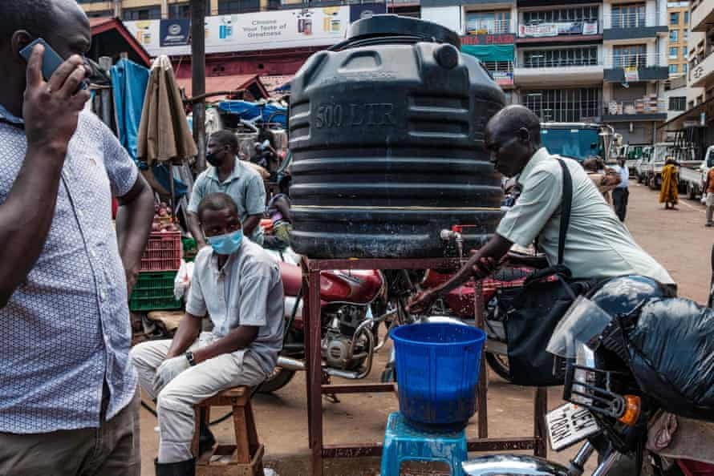
CAPTION: Uganda’s strict Covid restrictions were documented by Sadurni, whose work made the front page of the New York Times (Photo: Sumy Sadurni/AFP/Getty Images)
There were no half measures with Sadurni, and she threw her whole heart into both her work and her personal relationships, often becoming close friends with the people she photographed. Intimacy came easily in her presence. She became friends with a group of women who had survived acid attacks, taking them for drinks and walks on the shore of Lake Victoria, remaining friends long after her assignment ended.
“She used to treat everyone with love and respect”, said Linneti Kirungi, a member of the survivors’ group. “Our happiness was her happiness. She was a Ugandan.”
A lifelong heavy metal fan, Sadurni was hard to miss and impossible to forget, with her long black curls, red lipstick and biker boots, her ever-growing map of tattoos and her infectious laugh. Her mother, Maricarmen, described her as “a rock’n’roll Mother Teresa”.
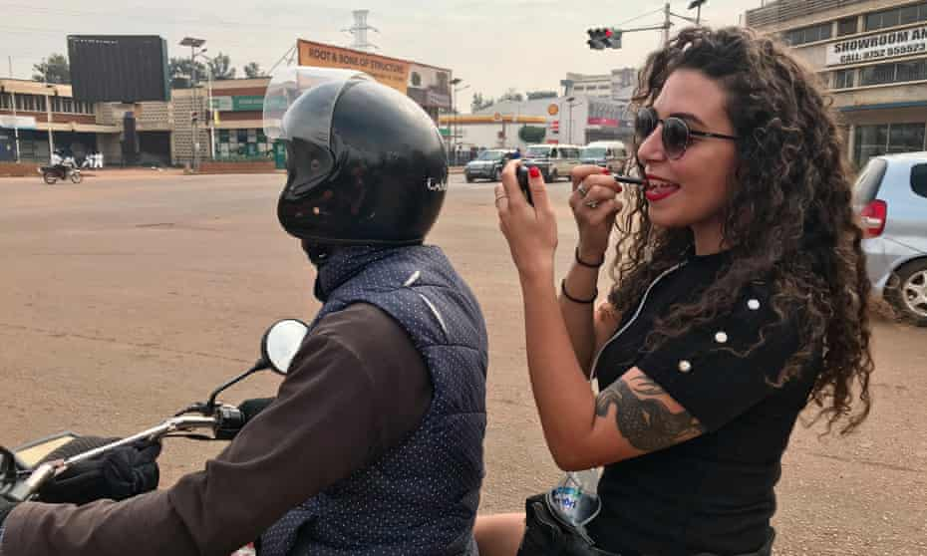
CAPTION: Sumy Sadurni was described as ‘creative, cool, considerate, compassionate, classy and collaborative’ (Photo: Michael O'Hagan)
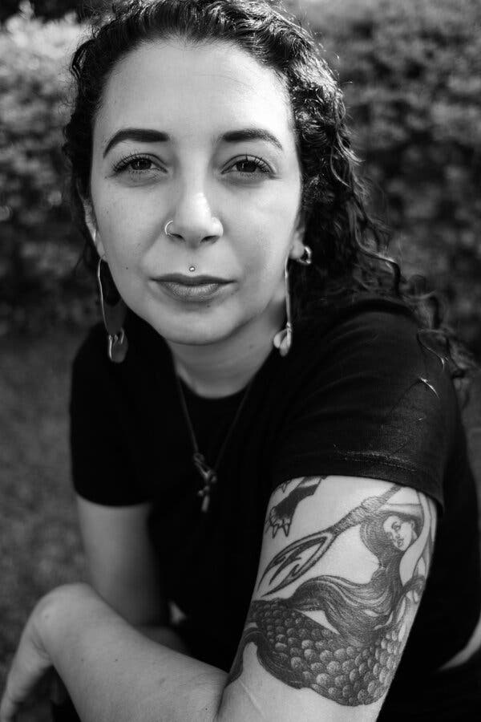
CAPTION: Ms. Sadurni in 2021. The subjects of her photographs, a friend said, “have power; they have dignity; they have autonomy.” (Photo: Chris Dennis Rosenberg)
Sadurni, a freelancer, traveled the world, but she was best known for her work in her adopted country, Uganda. Her photographs for Agence France-Presse (AFP) appeared in some of the world’s leading newspapers, including The New York Times.
She reported on the fractious 2021 presidential election in Uganda, focusing on Kyagulanyi Robert Sentamu a.k.a. Bobi Wine, the opposition leader who challenged President Yoweri Museveni.

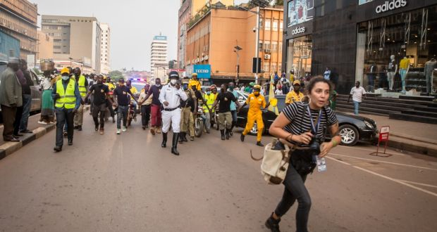
CAPTION: Sumy Sadurni runs ahead of President Yoweri Museveni’s convoy in Kampala Central (Photo: Sally Hayden)
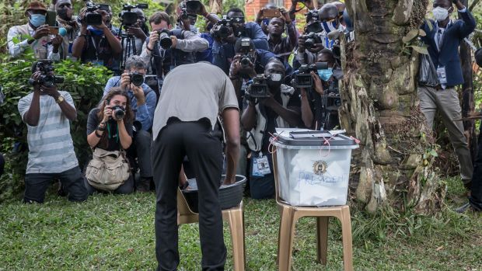
CAPTION: Sumy Sadurni among members of the press photographing Ugandan opposition leader Bobi Wine casting his vote in the January 2021 presidential election (Photo: Sally Hayden)
On the morning of the vote count, her AFP colleague, Michael O’Hagan said in an interview, he and Sadurni were at home with Bobi Wine. She was taking photographs before the results of the election were announced, but instead of focusing solely on him, she also took portraits of his wife, Barbie Kyagulanyi, an activist and political figure in her own right.
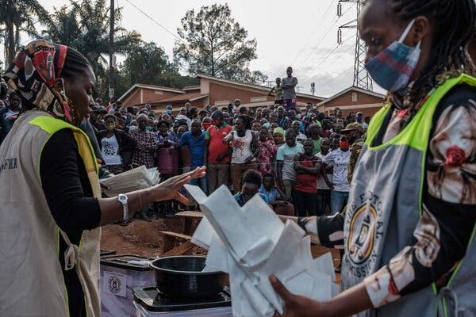
CAPTION: Counting ballots in Kampala in 2021, after a campaign that was violent, contentious and decried as unfair by outside observers (Photo: Sumy Sadurni/Agence France-Presse — Getty Images)
“It was classic Sumy,” O’Hagan said, “because she was mixing not just the headline political story about a Uganda opposition leader who was under great threat, but also coming at things from a different angle, examining Barbie’s perspective and her as an individual.”
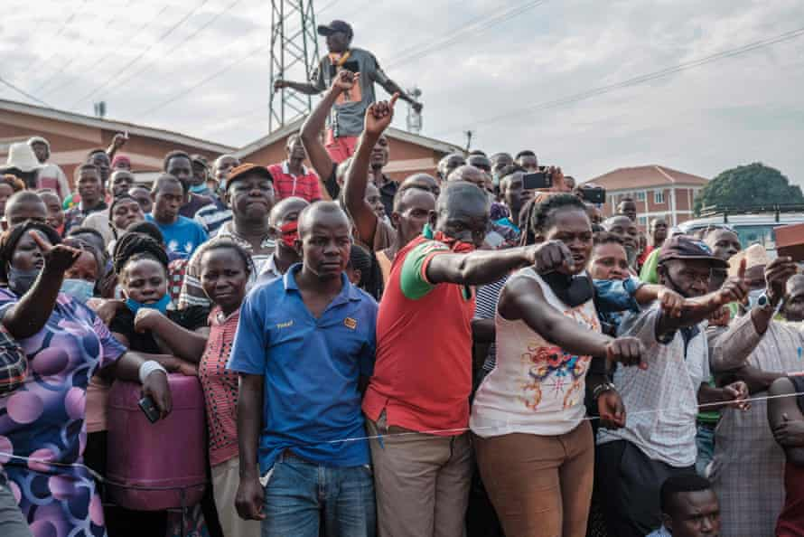
CAPTION: Sadurni’s shot of voters watching Ugandan electoral commission officials count ballot papers at a polling station in Kampala, January 2021 (Photo: Sumy Sadurni/AFP/Getty Images)
The election was a violent and contentious experience: some people were beaten, arrested and tear-gassed. Sadurni’s photographs took an unflinching look at this social turmoil, and she often found herself in the thick of violent marches and protests. In a remembrance on Twitter, Bobi Wine, who lost the election, wrote that she was never deterred from her work, even in the face of resistance.

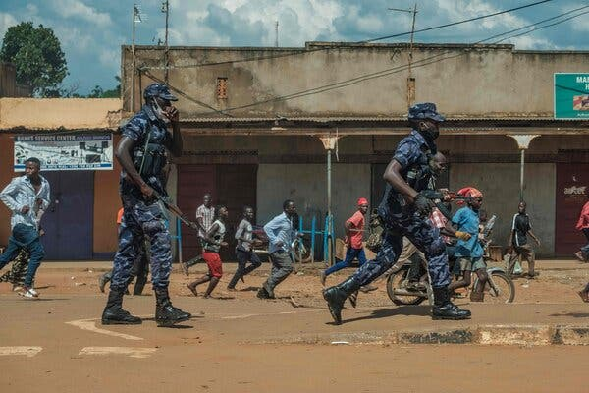
CAPTION: Sadurni photographed police officers dispersing a crowd in the town of Kayunga that had gathered in December 2020 (Photo: Sumy Sadurni/Agence France-Presse — Getty Images)

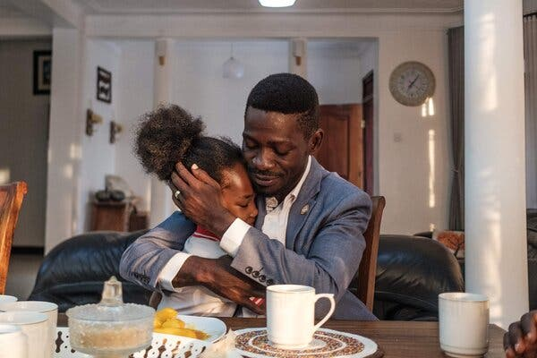
CAPTION: Bobi Wine and his daughter, Subi at his home in Kampala in December 2020 (Photo: Sumy Sadurni/Agence France-Presse — Getty Images)
Sadurni began working as a freelancer for AFP in January 2018, the organization said. She was a member of the International Press Association of Uganda, formerly known as the Foreign Correspondents’ Association of Uganda.
Many of her subjects and viewers especially connected to her work focused on gender. A major project of hers involved photographing survivors of acid attacks in Uganda, often used by men against their wives or girlfriends, as they formed a support group and lobbied for a law that would increase punishments for such acts.

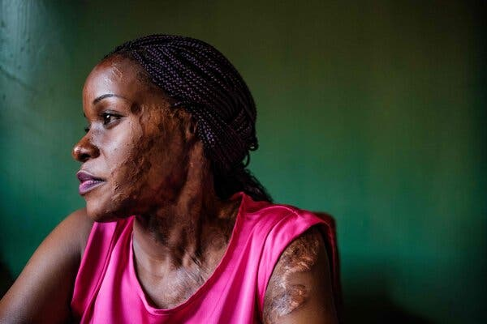
CAPTION: Linette Kirungi in 2019. She was one of the many victims of acid attacks in Uganda whom Sumy Sadurni photographed (Photo: Sumy Sadurni/Agence France-Presse — Getty Images)
Sally Hayden, a friend of Sumy Sadurni’s who covers Africa for The Irish Times, said in an interview that Sadurni’s work stood out because of her determination to represent her subjects’ autonomy and dignity.
She covered topics few journalists would touch, Hayden said, citing as an example her series of portraits of sex workers in Uganda as they organized after being denied governmental aid during the coronavirus pandemic.
Sadurni’s work was rare, Hayden added, because in representing Africa it shied away from “a stereotypical image of tragedy.” “The people in her photos,” she said, “have power; they have dignity; they have autonomy. Often they’re smiling.”
Sumaya Maria Sadurni Carrasco was born on Aug. 30, 1989, in Santiago, Chile, to Jorge Jose Sadurni Jammal and Maria Del Carmen DeCet Carrasco. She grew up in Chile and later lived in Mexico and Switzerland. She attended high school at the International School of Lausanne and went on to study journalism at University of the Arts, London. She then earned a bachelor’s degree in journalism from the University of Westminster. Her dissertation was on human rights coverage in Chile.
Sadurni moved to Uganda, Mr. O’Hagan said, after visiting a childhood friend and becoming enamored with the country. She is survived by her parents and her brother.
In addition to being an acclaimed photographer, Sumy Sadurni was a certified Canon photography trainer who offered guidance to young photojournalists in Uganda. After her death, she was remembered by many as a mentor.
Liam Taylor, a journalist who serves as co-chairman of the International Press Association of Uganda, said in a statement: “We marveled at her pictures. We were moved by them. But if you want to find her legacy, look for it in the young photographers she mentored and inspired. They are still out there, taking the pictures that she no longer can.” May her soul rest in eternal peace!

