MEDIA COUNCIL OF UGANDA HOSTS COUNTERPARTS FROM ETHIOPIA
By Lillian Parmu
The Media Council of Uganda hosted a five-member delegation from the Ethiopia Media Council from 28th February to 3rd March, 2022 to exchange experiences.
The Ethiopian Media Council, which had just set up an arbitration tribunal for the media and journalists back at home, was headed to Kampala, Uganda to gain experience in its initial campaign.
The delegation was welcomed by their counterparts, members of The Media Council of Uganda, headed by the Chairperson, Mr Paulo Ekochu who thanked the guests for choosing Uganda for experience sharing.
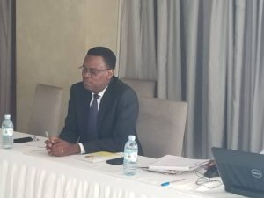
Chairman, Media council of Uganda, Mr Paulo Ekochu gives an overview of the Council’s activities as he hosted the Ethiopian delegation who had visited the Council to share experiences, at Sky’s Hotel, Naguru on 1st March, 2022.

Ekochu, gave a brief overview of the organizational structure of the council, its purpose and function, conflict and resolution system, challenges and opportunities. He asserted that the Council was a statutory body working independently and impartially.
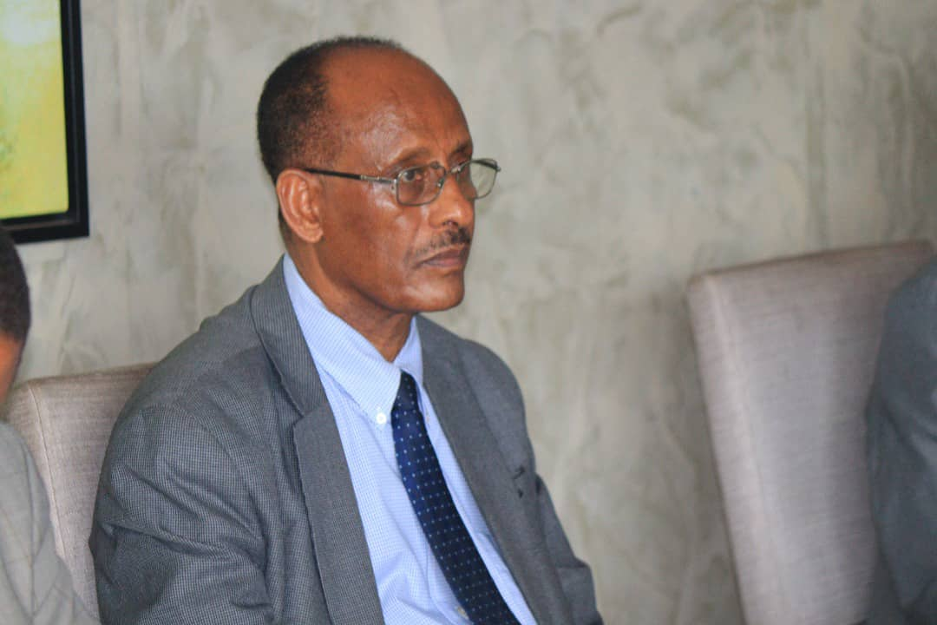
Mr Hailu Tamerat, Member, Executive Committee of the Ethiopian Media Council briefed hosts and counterparts of Media Council of Uganda on activities of the Ethiopian Media Council, at Sky’s Hotel, Naguru on 1st March, 2022, where they had met to share experiences.
Mr Tamerat Hailu, member of executive Committee of the Ethiopian delegation also briefed his hosts on the organizational nature of the Ethiopian Media Council and its start-up activities. He said it had been three years since the council received its legal mandate, but it was in the final stages of setting up an arbitration tribunal funded by the Embassy of France in Ethiopia. The council shall receive complaints from the public, the government and the media, he added.
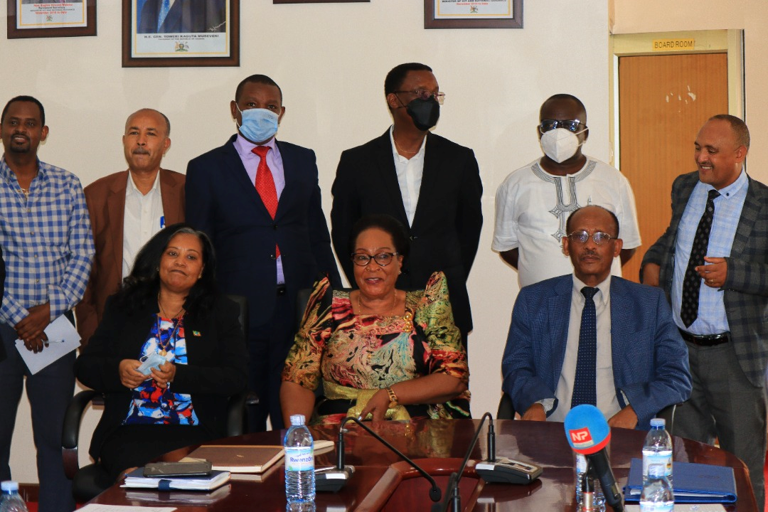
The State Minister for Information, Communications Technology, Hon. Mrs. Joyce Nabbosa Ssebugwawo (middle), hosts the Ethiopian Ambassador to Uganda, H.E Alemtsehay Meseret Gelaw (left) and the Ethiopian Media Council Team and their counterparts from Media Council of Uganda at the Ministry offices where they had a paid a courtesy call on her on 2nd March, 2022.
Media Council of Uganda, which was established by law in 1995, is partly funded by the government. On the other hand, the Ethiopian Media Council is sponsored by professionals and the source of funding comes from its members’ contributions and various sources of revenue, but does not receive government funding.
The visiting delegation visited the government owned national broadcaster, Uganda Broadcasting Corporation, Next Media which is privately-owned and the government-owned New Vision newspaper editing suites. The delegation also visited Makerere University Department of Journalism and Communication Studies as well as the Uganda National Museum.
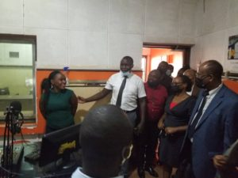

Ethiopian Media Council with their hosts and counterparts, Media Council of Uganda visiting Uganda Broadcasting Corporation studios, as they carried out media house visits on 2nd March, 2022.

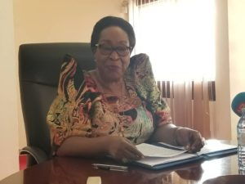
The State Minister for Information and Communications Technology, Hon. Mrs. Joyce Nabbosa Ssebugwawo hosted the Ethiopian Media Council Team and their counterparts from Media Council of Uganda at the Ministry offices when they paid a courtesy call on her on 2nd March, 2022.
The State Minister for Information and Communications Technology, Hon. Mrs Joyce Nabbosa Ssebuggwawo expressed her gratitude to the Ethiopian Media Council for coming to Uganda for the exchange of experiences.
“It is a good start for the two countries to work together on media freedom,” she said.
On her part, the Ethiopian Ambassador to Uganda, H. E. Alemtsehay said the exchange of experiences between the media councils of the two sister countries was of great value to Ethiopia in addition to the importance of building a free and responsible media.
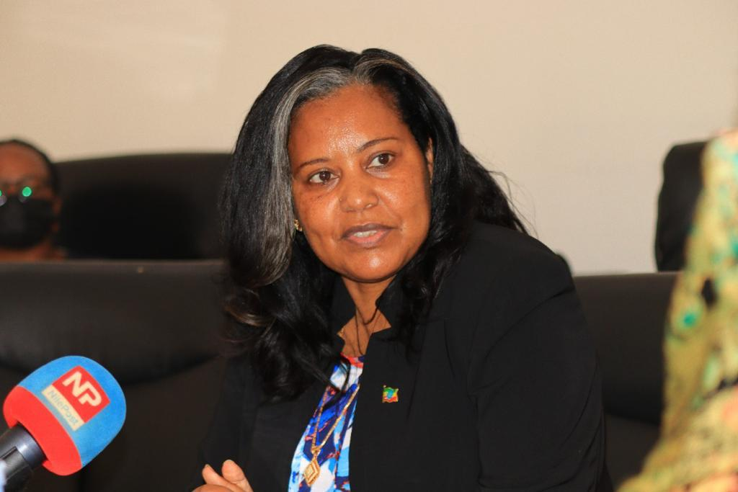
H.E Alemtsehay Meseret Gelaw, Ethiopian ambassador to Uganda addresses officials during the courtesy visit at the Ministry of Information Communications Technology on 2nd March, 2022.

“Ethiopia and Uganda are the main sources of the Blue Nile and the White Nile,” Alemtsehay stated. The two countries’ media professionals and their councils have a great responsibility to enhance this relationship, she added.
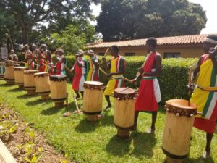\
The Ethiopian Media Council were entertained with a cocktail function at the Ndere Troupe Cultural Centre, Kisaasi, with traditional Ugandan music and food at a farewell ceremony.

The farewell ceremony which was a mix of a spectacular traditional music performance at the famous Ndere Troupe Cultural Centre and exchange of gifts from the Ugandan counterparts to their visitors. The Ethiopian Media Council and the media Council of Uganda plan to sign a memorandum of understanding to work more closely in the near future.
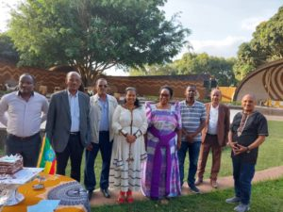
State Minister for Information and Communications Technology, Hon. Mrs. Joyce Nabbosa and the Ethiopian ambassador, H.E Alemtsehay Meseret with Ethiopian Media Council delegation at the Ndere Troupe Cultural Centre where hosts Media Council of Uganda bid farewell to their visitors on 3rd March, 2022.

